**Cloud Datapipeline**

**Yash Bhatnagar**

**Abstract**

This project, titled "Cloud Data Pipeline Mastery: End-to-End Analytics with AWS," focuses on building a versatile and scalable data engineering pipeline using AWS services to analyze and visualize any dataset. For this implementation, we used the Spotify dataset, but the architecture is designed to accommodate any dataset, making it suitable for a wide range of real-world applications in data-driven decision-making. By leveraging AWS Glue, S3, Athena, CloudWatch and QuickSight, this project provides an efficient, scalable, and cost-effective solution for processing and analyzing data, offering valuable insights to stakeholders.

**Introduction**

In this project, we will build a comprehensive data engineering pipeline using AWS cloud services. While we demonstrate the pipeline with the Spotify dataset, the project architecture is flexible enough to handle any dataset. The focus is on processing and analyzing data using various AWS tools like S3, Glue, Athena, and QuickSight.

**Project Architecture Overview**

* **Staging Layer**: Raw data is stored in an S3 bucket.
* **ETL Pipeline**: AWS Glue processes and transfers data from the staging layer to the data warehouse.
* **Data Warehouse**: Processed data is stored in another S3 bucket.
* **Data Catalog**: AWS Glue Crawler creates a database and tables for the data warehouse.
* **Data Analysis**: AWS Athena queries the processed data.
* **Data Visualization**: AWS QuickSight visualizes the data.

.

**AWS Services Used**

* **Amazon S3**: For storing raw and processed data.
* **AWS Glue**: For building and managing ETL pipelines.
* **AWS Athena**: For querying data using SQL-like syntax.
* **AWS QuickSight**: For visualizing data.
* **AWS CloudWatch** monitoring, logging, and alerting across our data pipeline.

**Data Source**

The data used in this project is sourced from the [Spotify Dataset 2023](https://www.kaggle.com/datasets/tonygordonjr/spotify-dataset-2023) available on Kaggle. The dataset, created by Tony Gordon Jr., includes detailed information about Spotify albums, artists, tracks, and various audio features like danceability, energy, loudness, and more. Although this project uses the Spotify dataset, the pipeline is designed to be dataset-agnostic.

**Data Description**

* **Albums**: Contains details of all the albums, including album ID, name, popularity, and release date.
* **Artists**: Contains information about the artists, including their names, number of followers, and genres.
* **Tracks**: Contains track-level data, including track ID, popularity, and other features like danceability and energy.
* **Spotify Features**: Contains various audio features like loudness, mode, speechiness, and valence

**Project Implementation**

**Creating S3 Buckets**

We set up S3 buckets to store raw and processed data. The staging folder in the S3 bucket will hold the raw data files, while the data-warehouse folder will store the processed data. This separation ensures organized storage and easy retrieval of data at different stages of the pipeline.

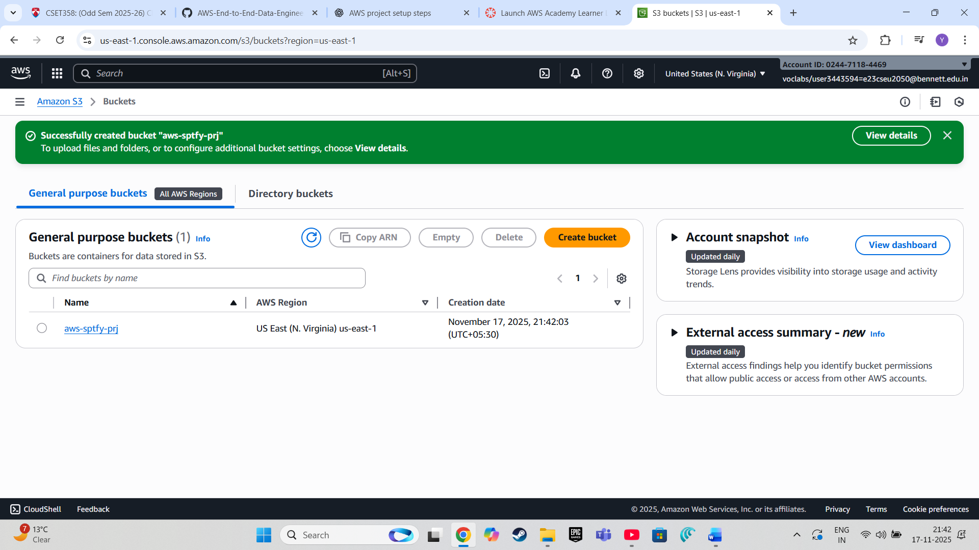

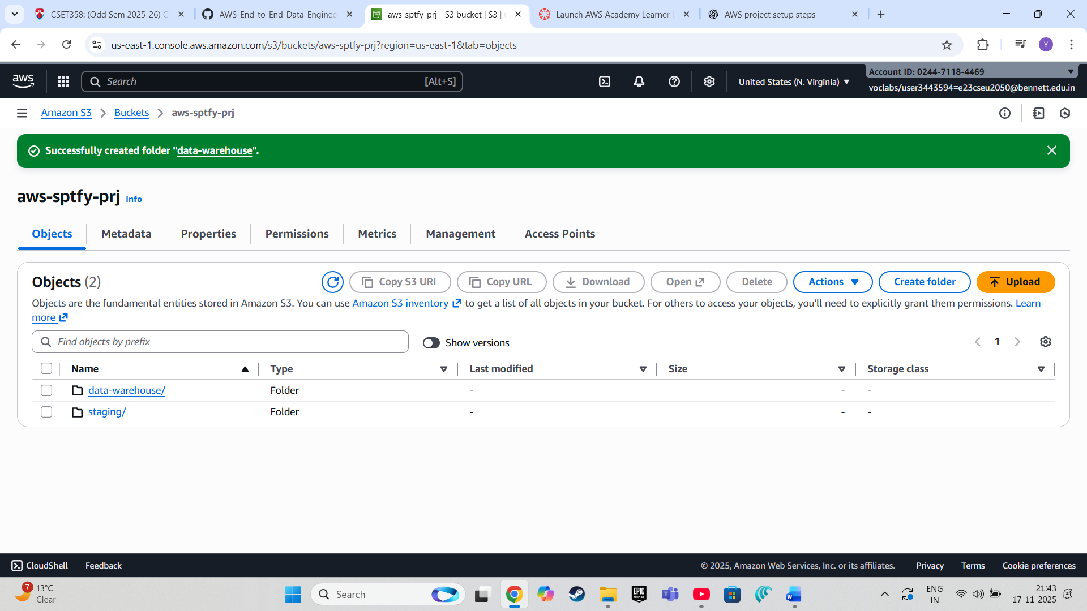

We upload the csv files in the staging folder

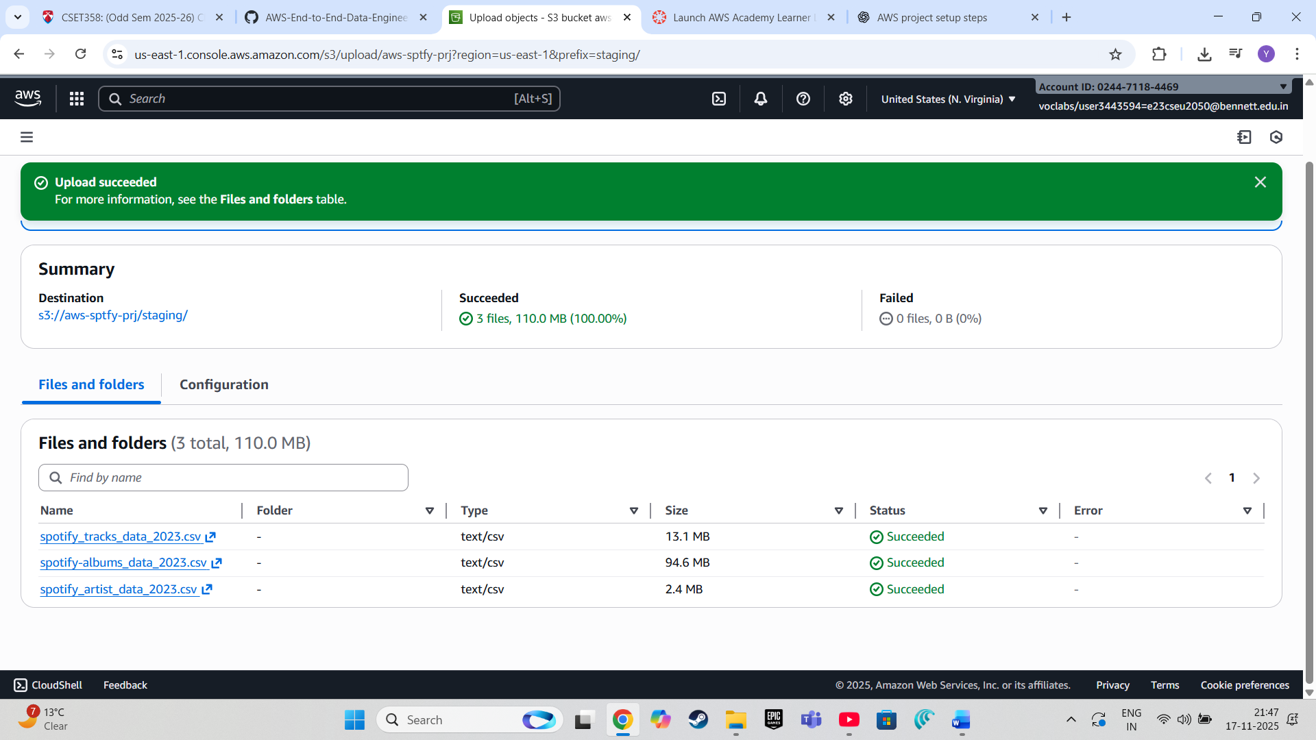

**Setting Up AWS Glue for ETL**

AWS Glue is used to create a data pipeline that automates the process of extracting data from the staging folder, transforming it by joining and cleaning the data, and then loading it into the data-warehouse folder. This step highlights the power of Glue in managing ETL (Extract, Transform, Load) operations seamlessly.

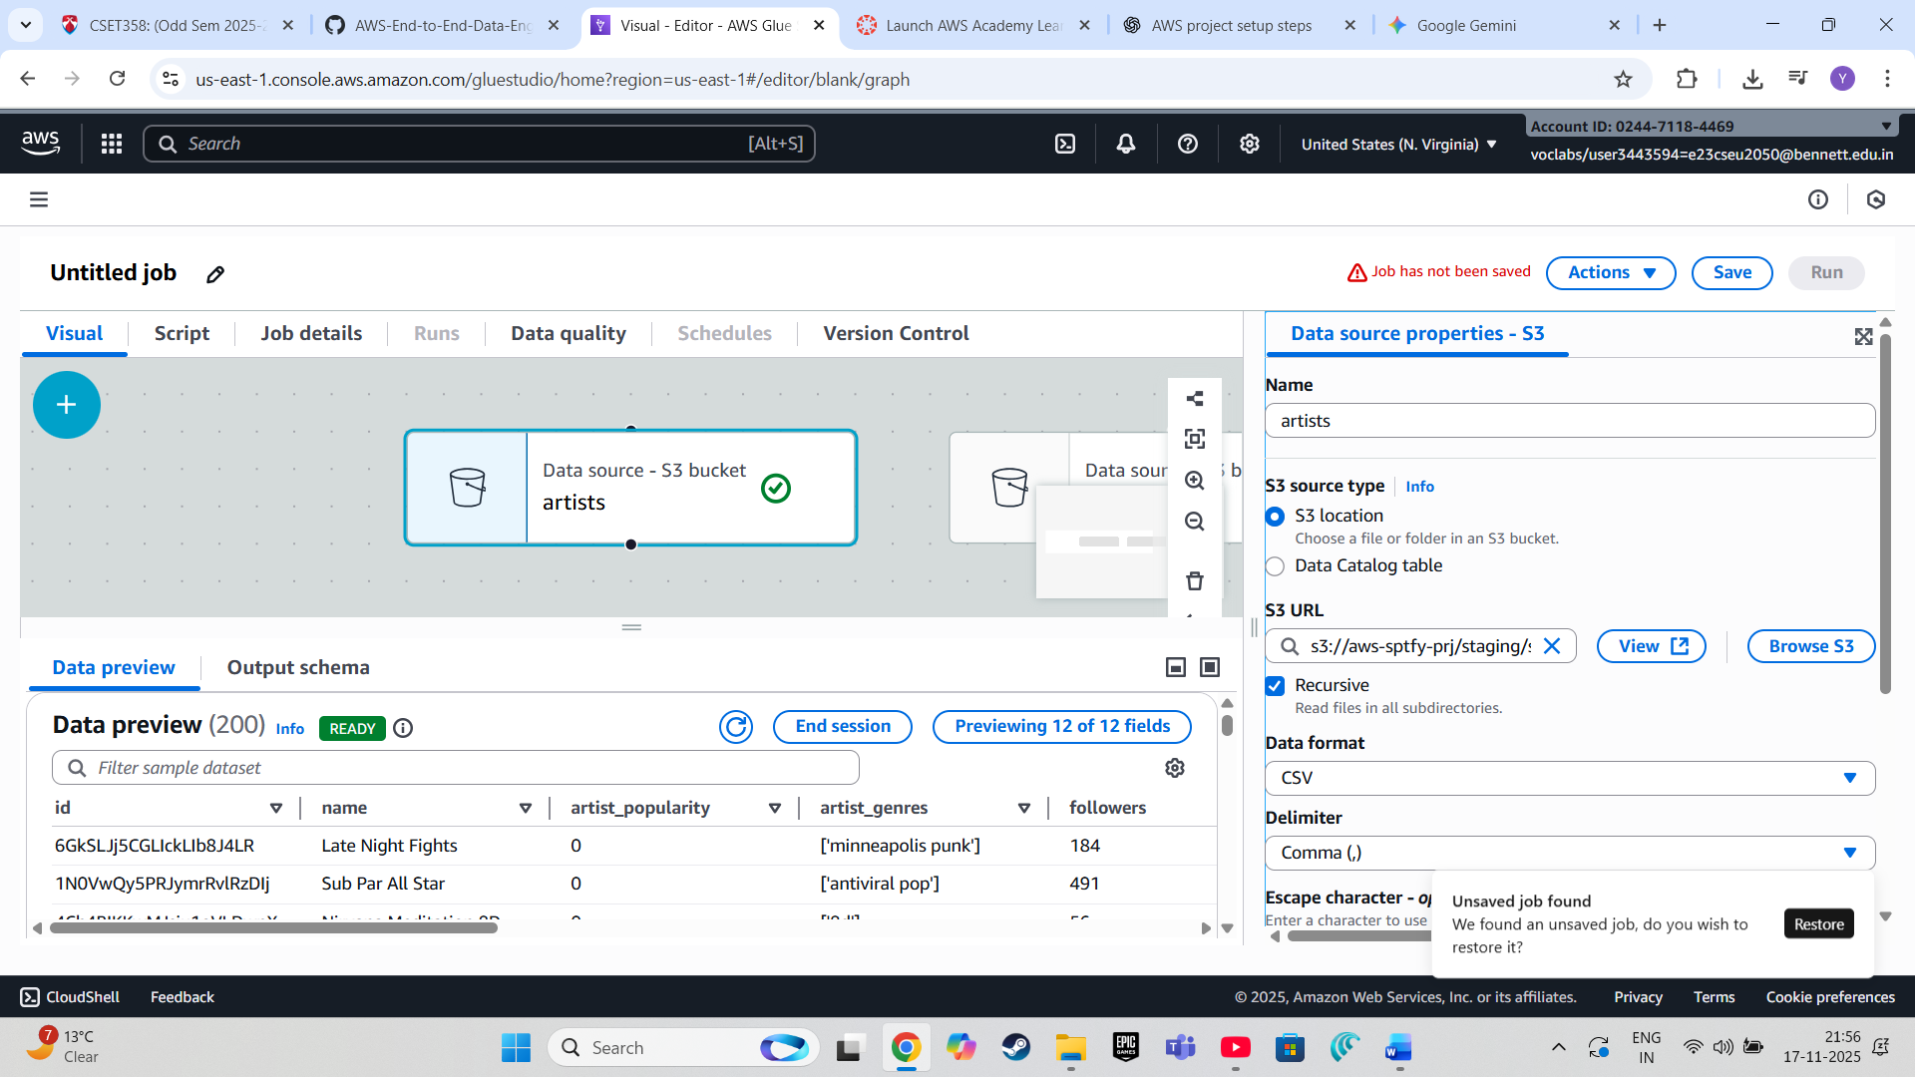

* Select the **First Amazon S3 bucket** and rename it with **“artist”** and click on **browse** and select the file from the **s3://spotify-aws-prjct/staging/spotify_artist_data_2023.csv**. Select the **Data format as CSV**.
* Repeat the step for the other two

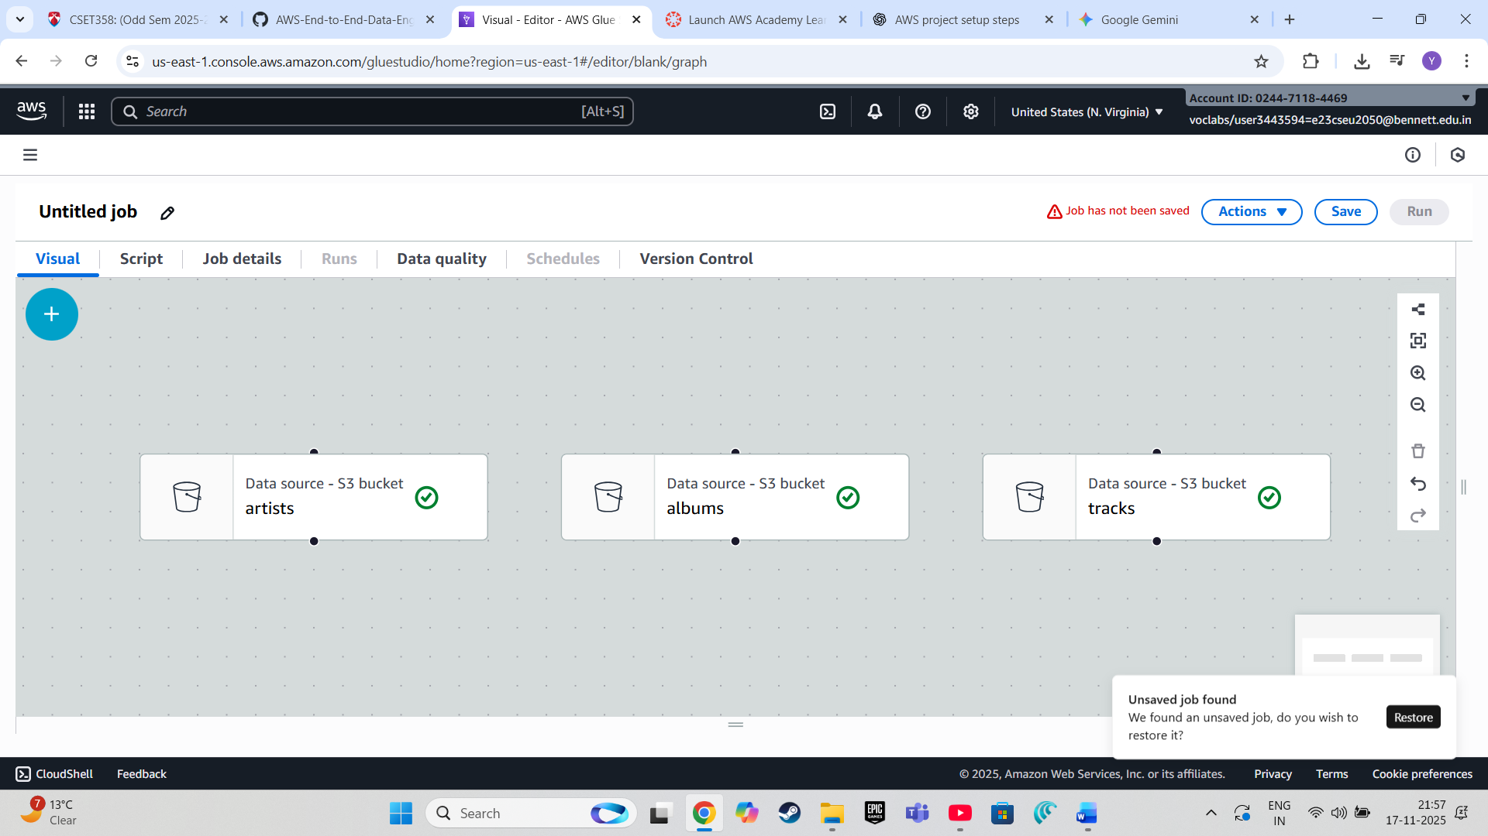

**4. Configure Data Transformations:**

* Now to join **album** and **artist**, click on the **ADD symbol**, select **join** from **Transforms** and connect nodes as per the image below.

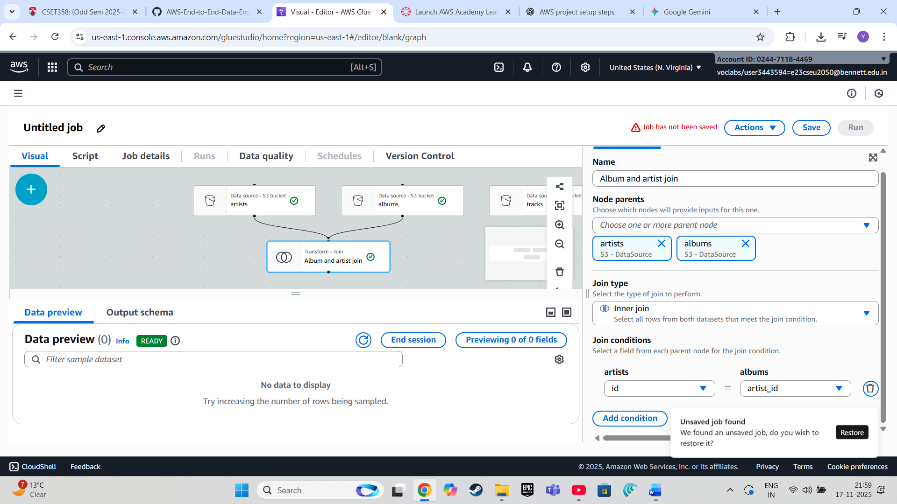

* After Joining the nodes of both the buckets to the **Join Transform**. Add a Condition where **artist 'id' = albums 'artist_id'** and rename the join **“Album and Artist Join”**.

Now add another **Join Transform** to join **‘track’ S3 bucket** and **‘Album and Artist’ Join**.

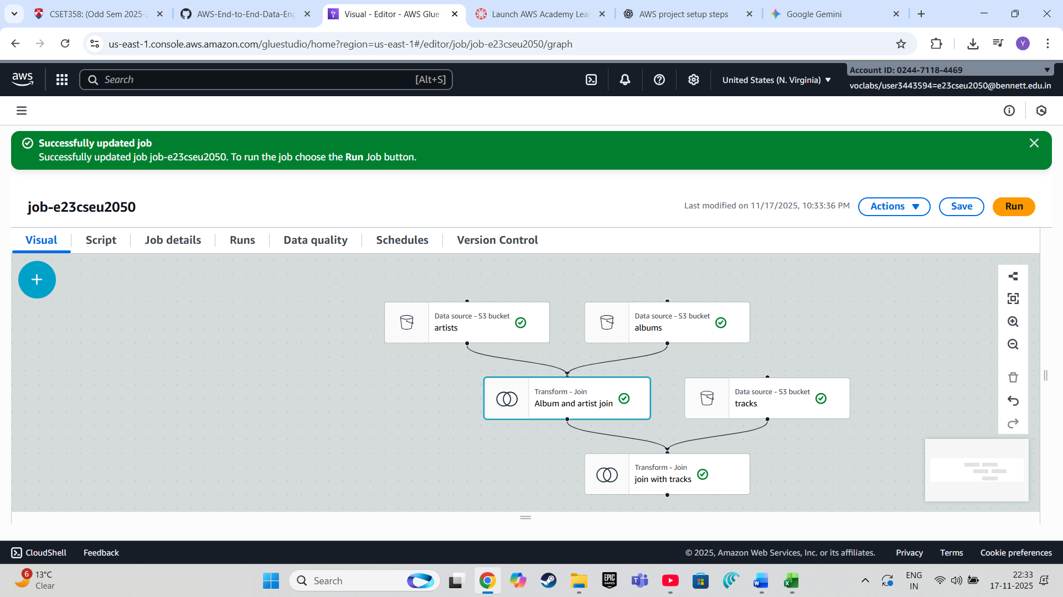

Now select the **Join** and add the condition **Album and Artist Join ‘track_id’ = tracks ‘id’** and rename the join as **‘Join with Tracks’**.

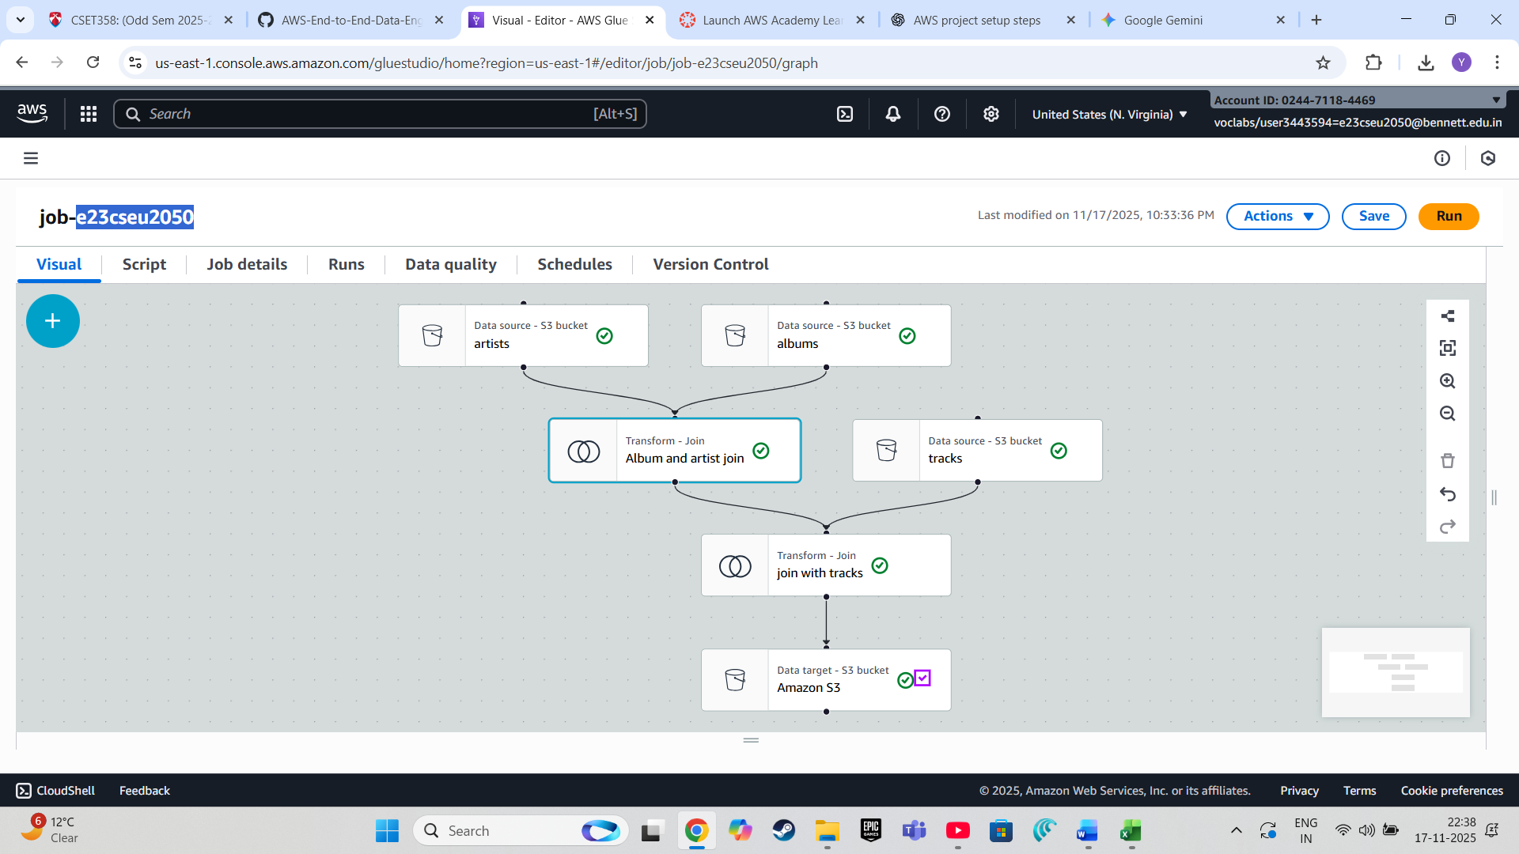

**Rename the Destination node and add the Target location and make sure the compression type is Snappy.**

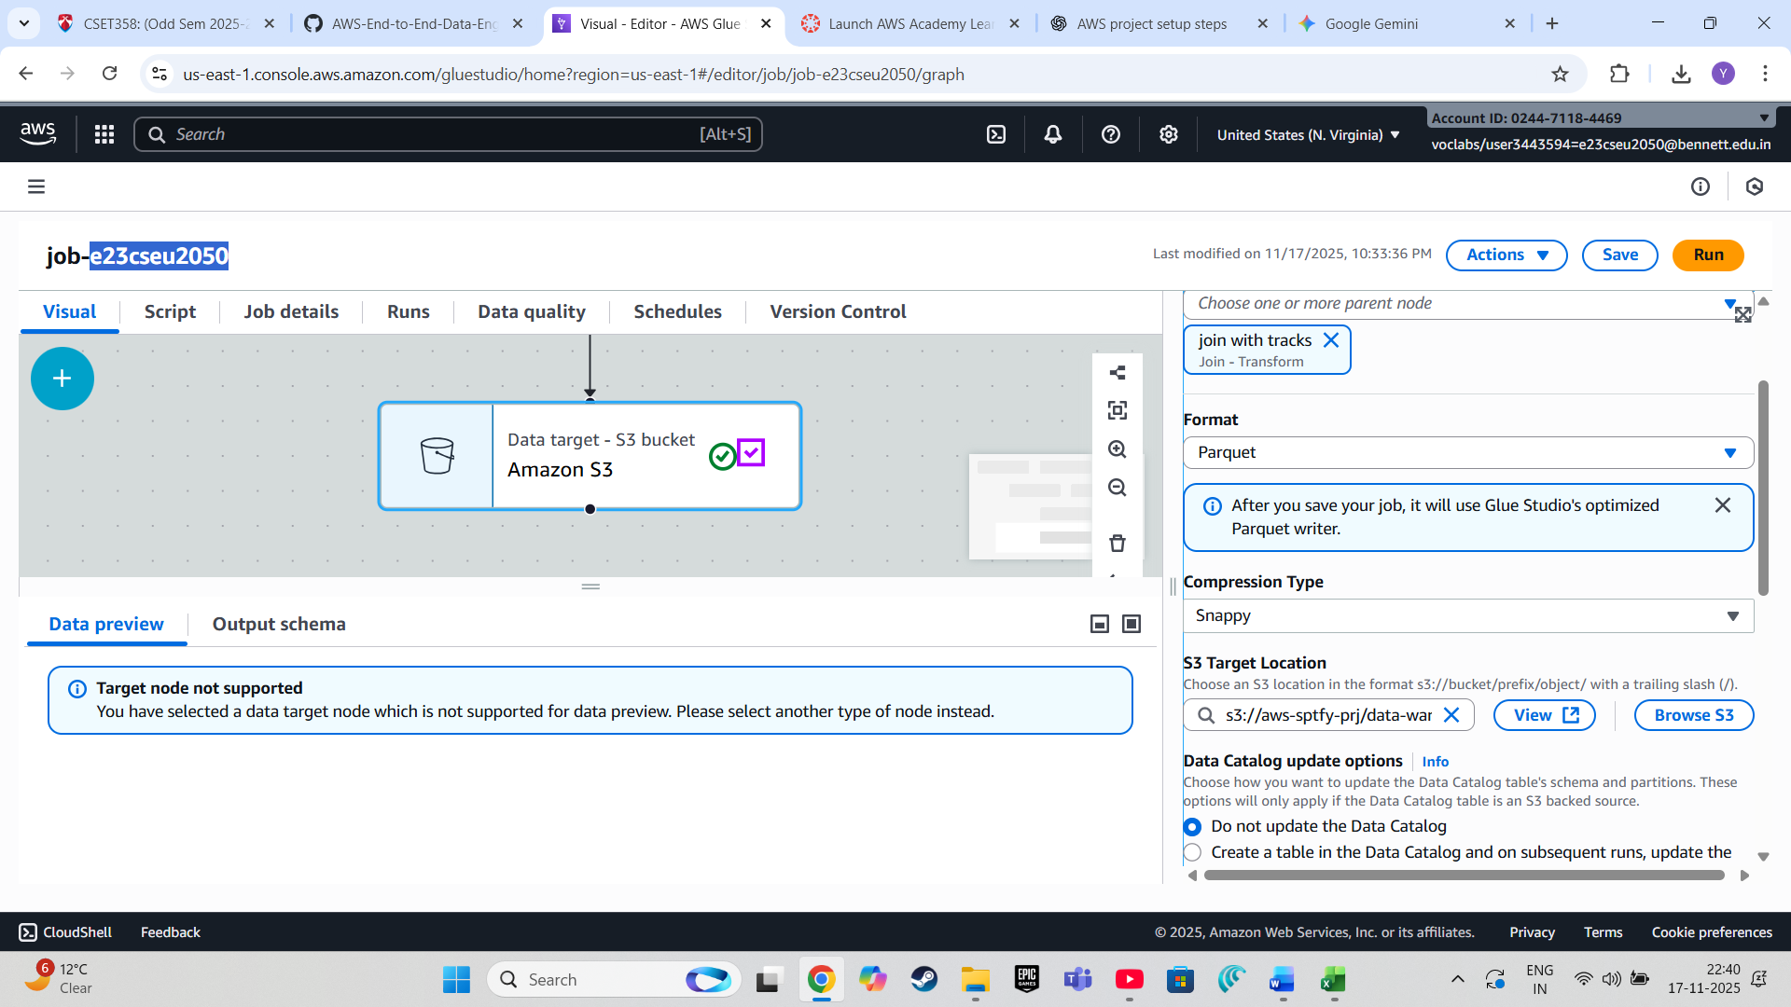

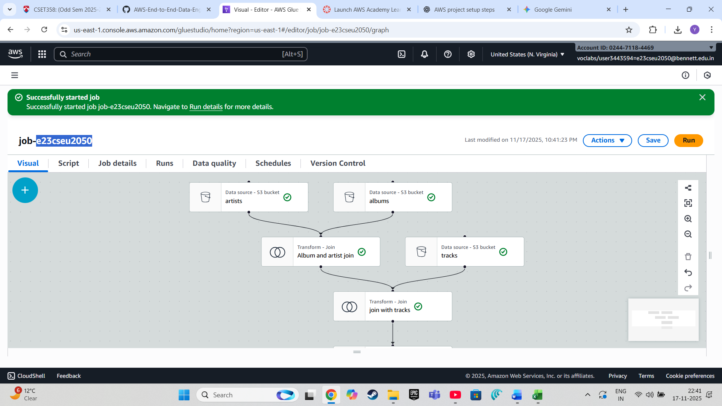

**6. Run the Glue Job:**

* **Review your job settings.**
* **Click "Run job" to start the ETL process, transforming and moving data from the staging layer to the data warehouse.**

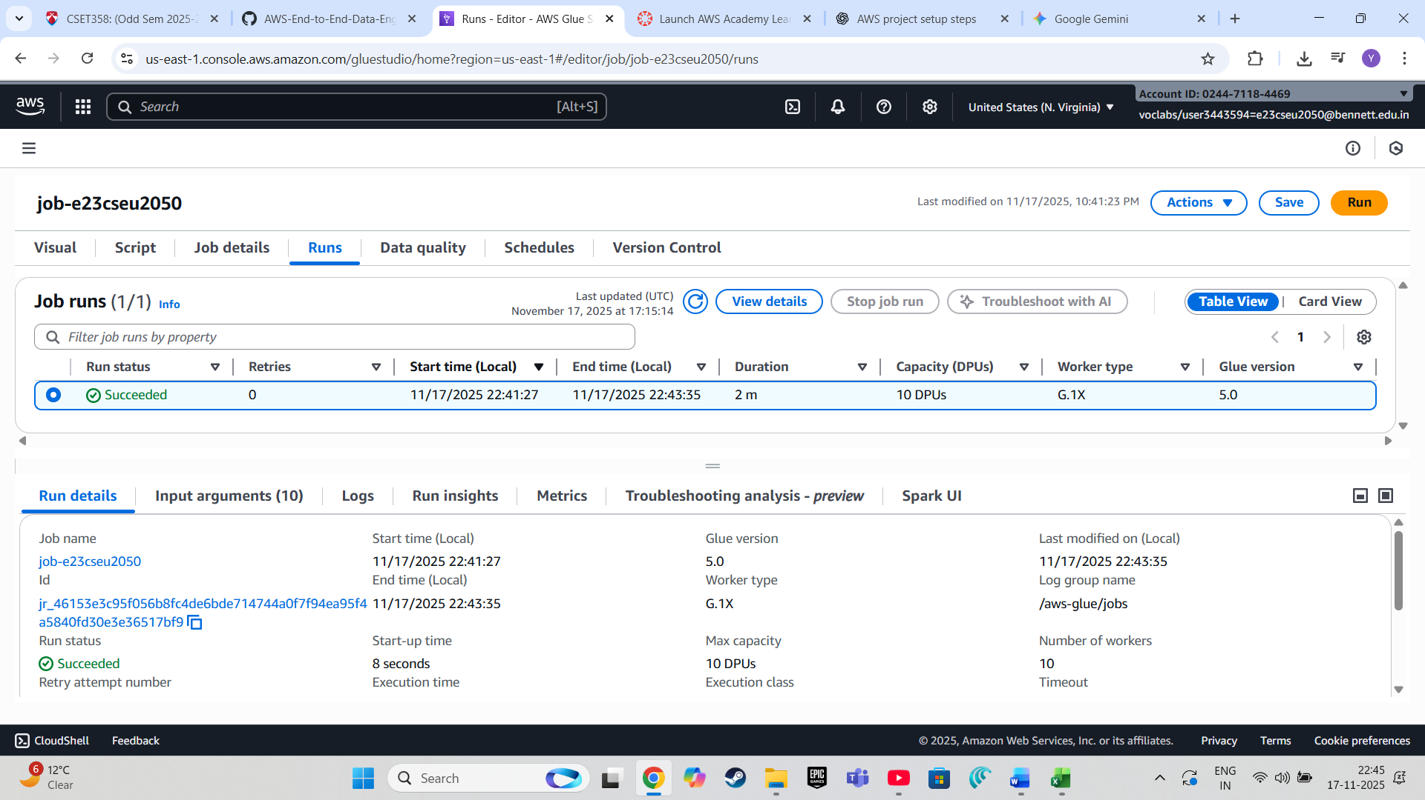

**Check S3 bucket if the files are Parsed.**

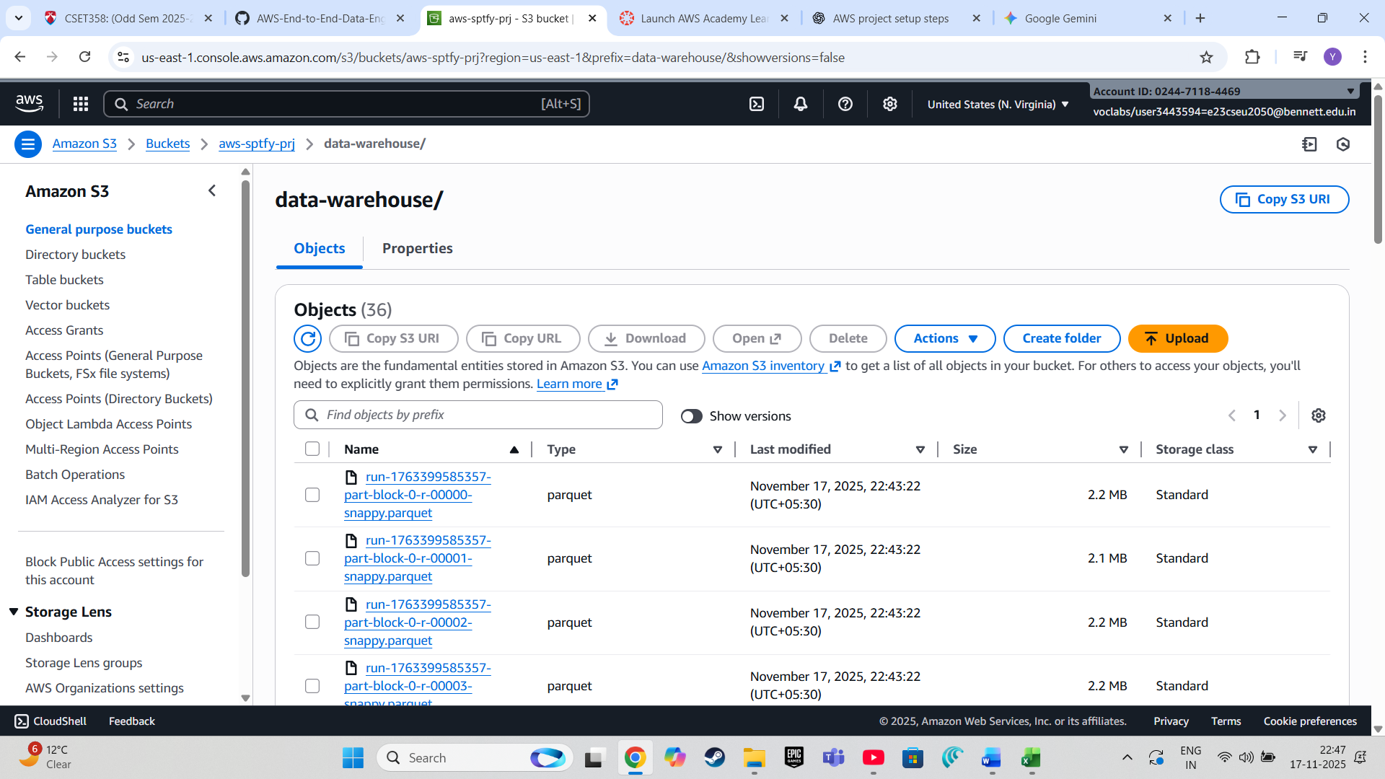

**Step 4: Creating a Data Catalog with AWS Glue Crawler**

1. **Create a New Crawler:**
   * **In the AWS Glue dashboard, click on "Crawlers" under the "Data catalog" section.**
   * **Click "Create crawler."**

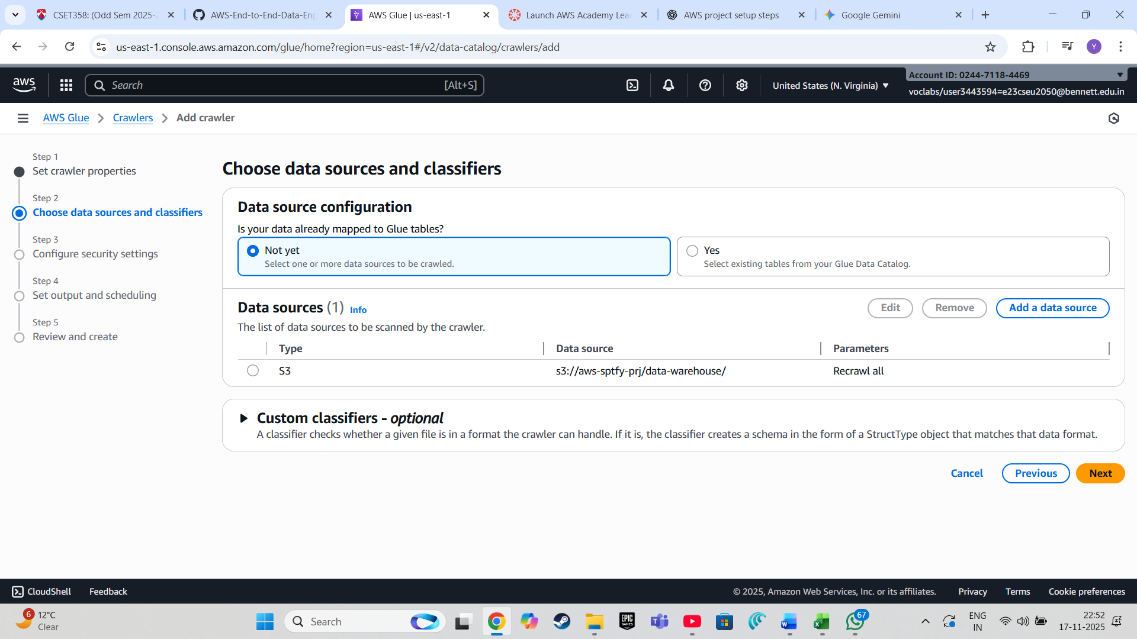

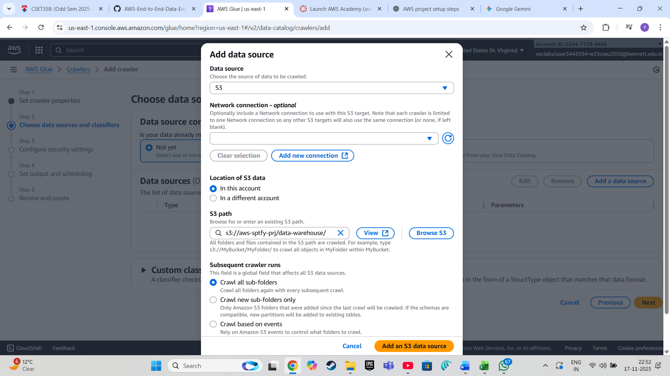

**2. Create a New Database:**

* **Open the duplicate tab. Go to the AWS Glue > Data catalog >> Databases, and create a new database.**

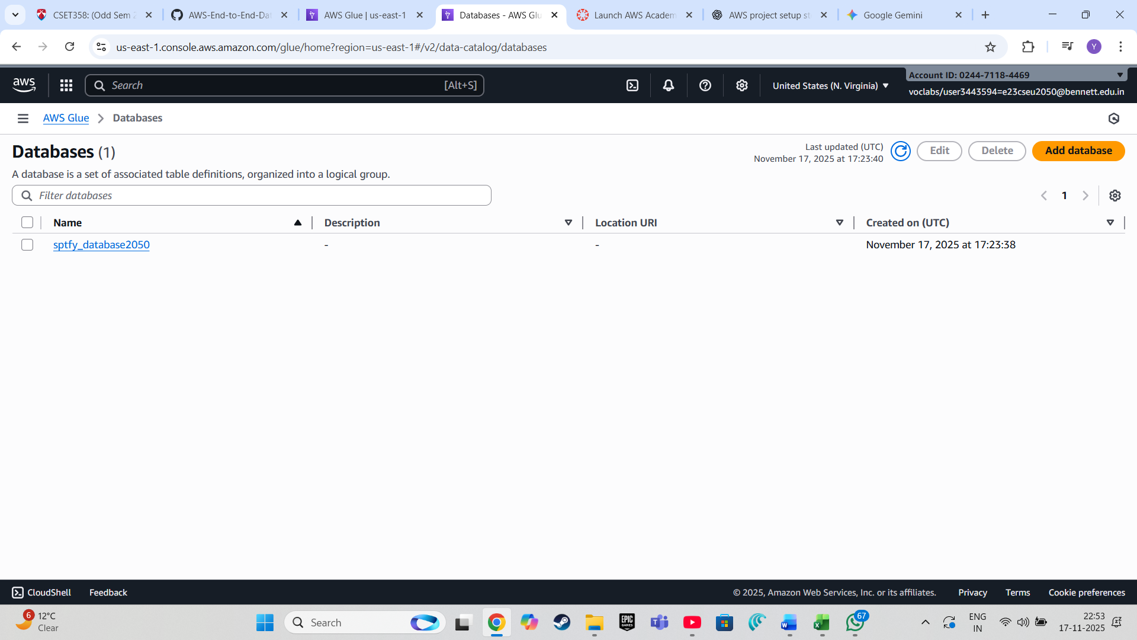

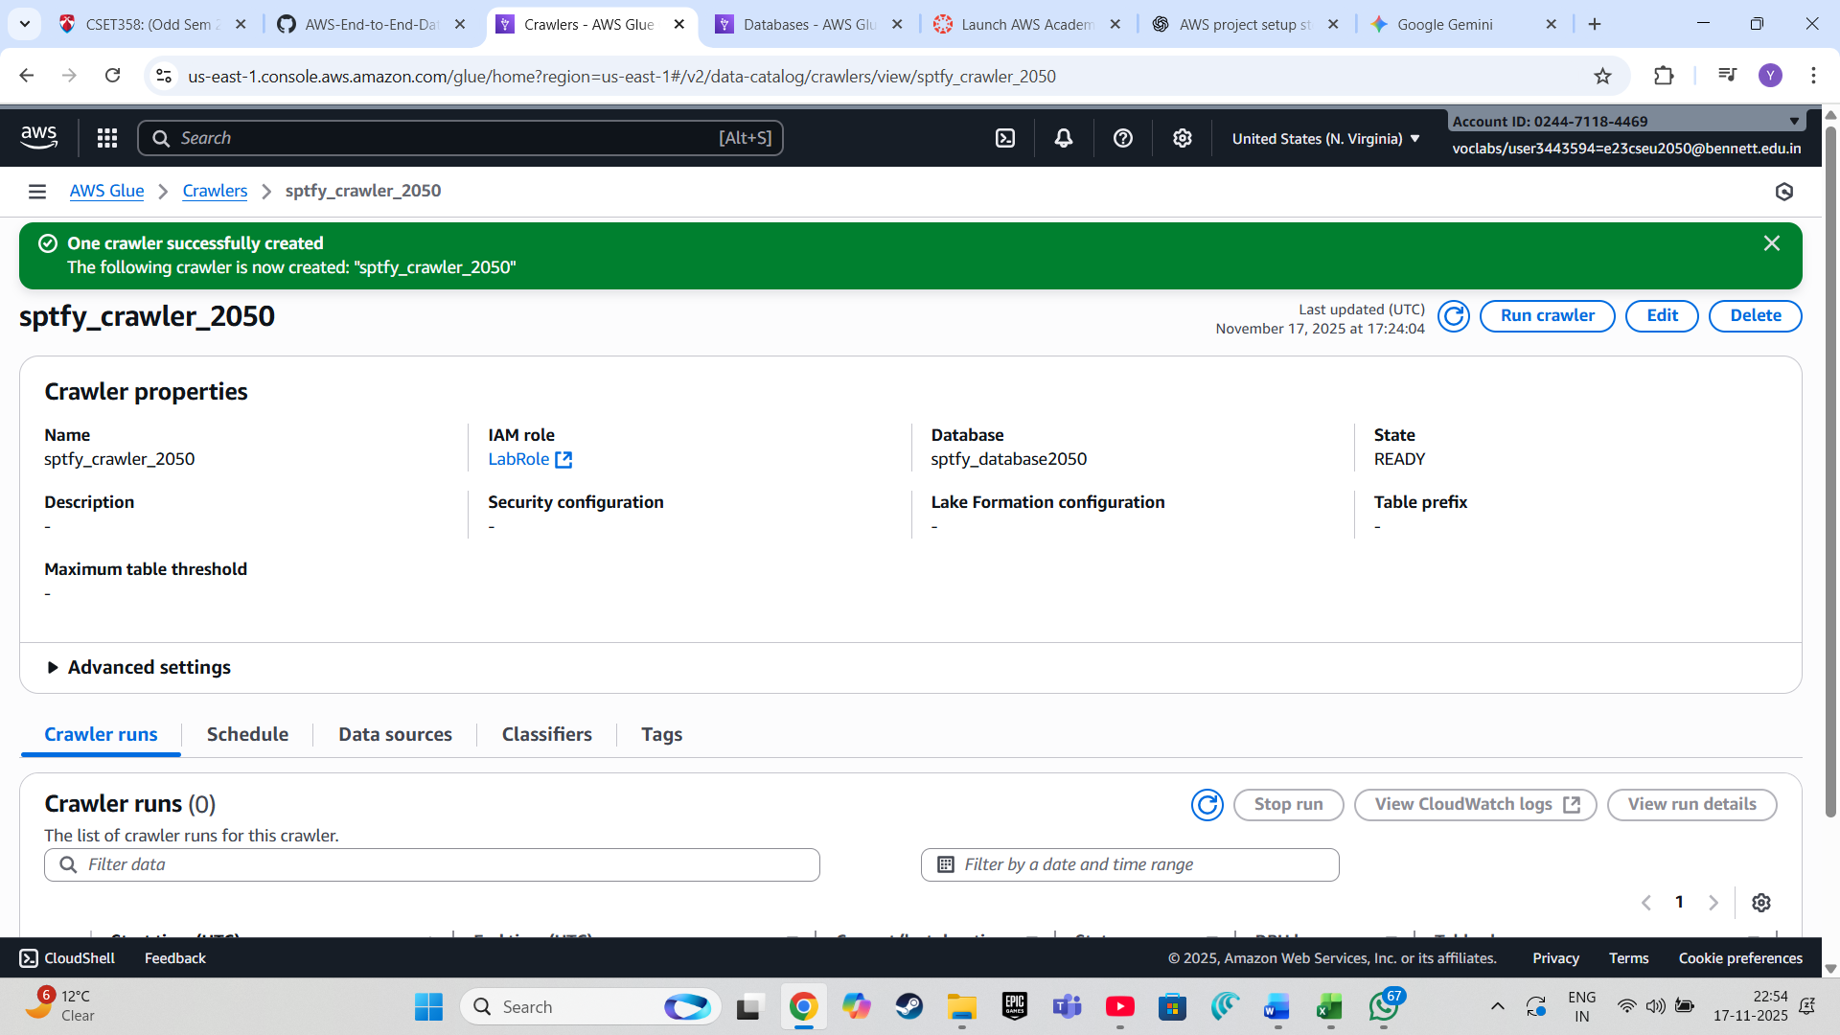

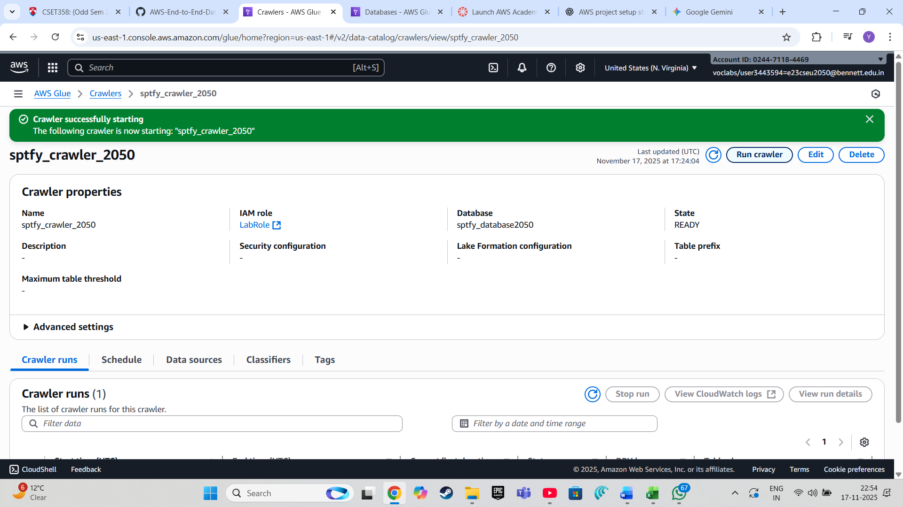

The crawler will scan the data in the **data-warehouse** folder and create corresponding tables in the **spotify_data** database.

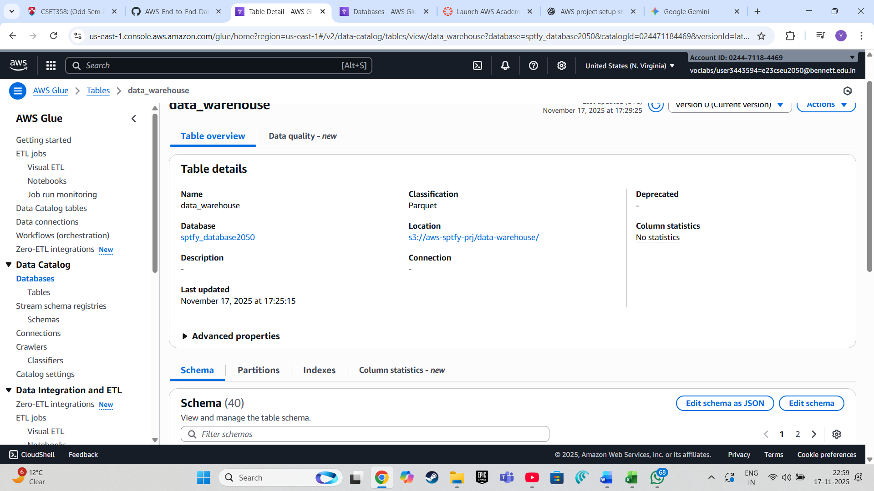

**Step 5: Querying Data with AWS Athena**

1. **Set Up Query Result Storage:**
2. Navigate to **AWS Athena** from the **AWS Management Console**
3. Before running any queries, you must specify a location for query results. Create a new **S3 bucket** named **sptfy-proj-athena-output**.

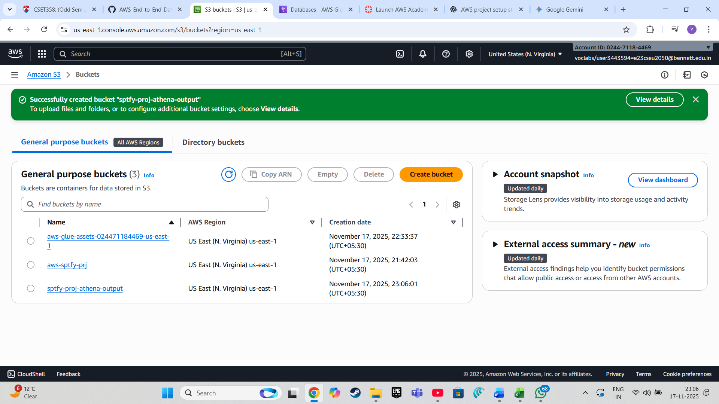

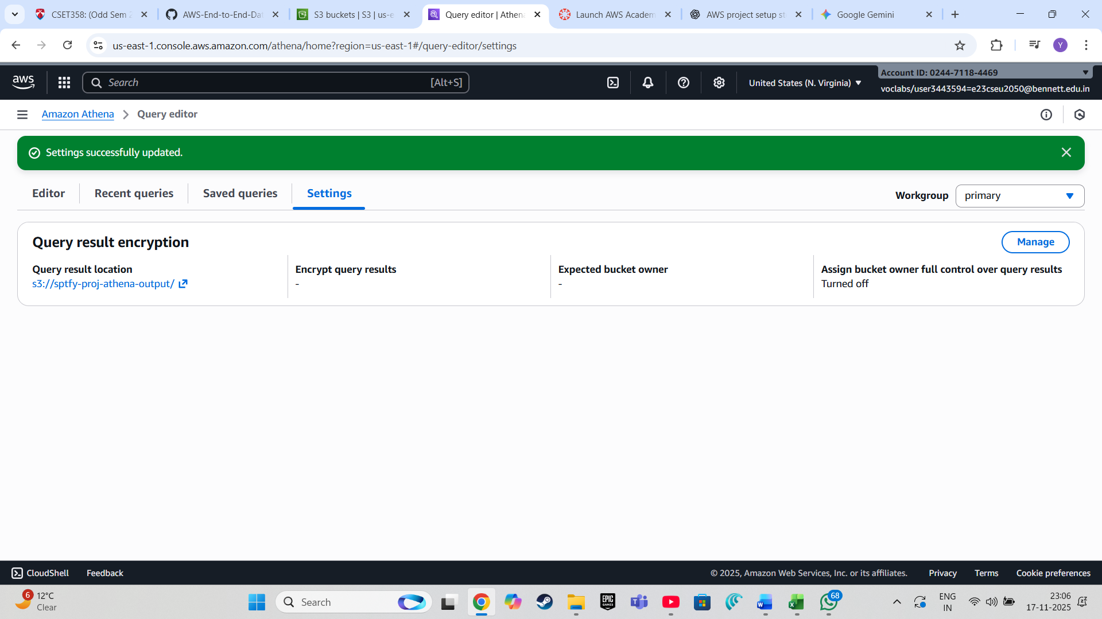

The results will be displayed in the **query editor**, and the output will be saved in the specified **S3 bucket (athena-output)**.

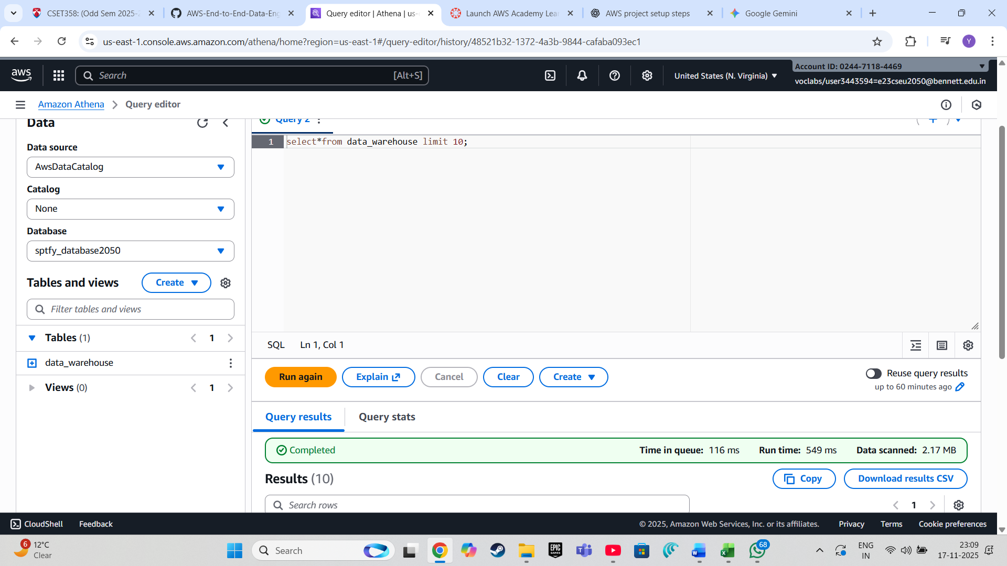

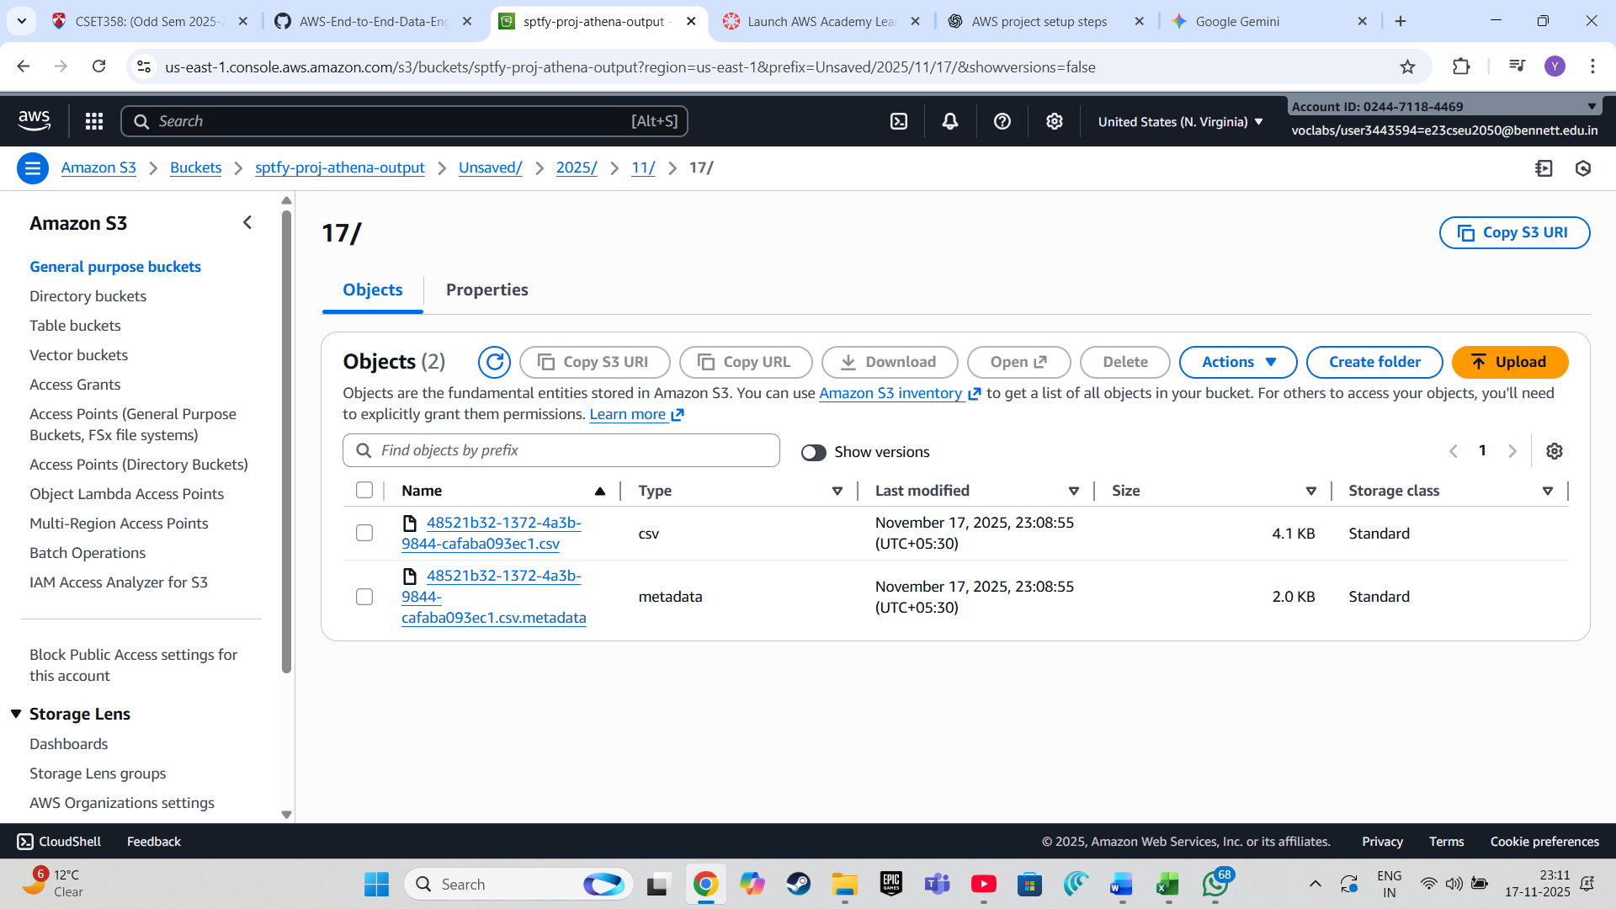

**Step 6: Visualizing Data with AWS QuickSight**

**Connect QuickSight to Athena:**

Once signed in, go to **"Datasets"** and click **"New dataset."**

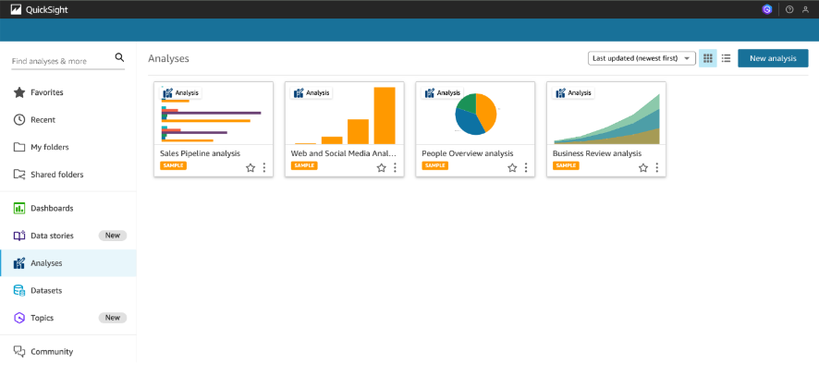

• Select **"Athena"** as the data source and name it with **SpotifyQsData**

• Choose the **spotify_data** database and the **data_warehouse** table.

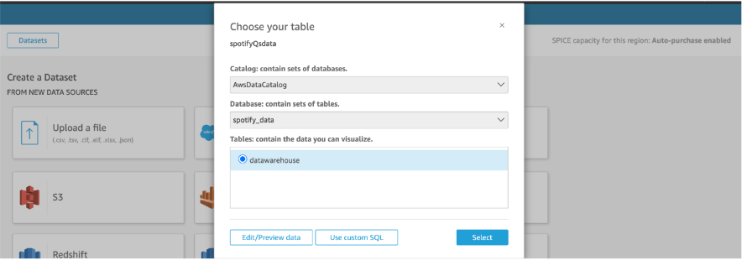

**Create Visualizations:**

* After importing the data, you can create various types of visualizations (e.g., **bar charts**, **line charts**, **pie charts**) using the fields from the **data_warehouse** table.
* **Example:** Create a bar chart to visualize the popularity of tracks by artist.

**4. Publish and Share Dashboards:**

* Once your visualizations are ready, you can **publish the dashboard** and share it with stakeholders.
* Click **"Publish dashboard"** and follow the prompts to share it via email or a link.

**Step 7: AWS CloudWatch**

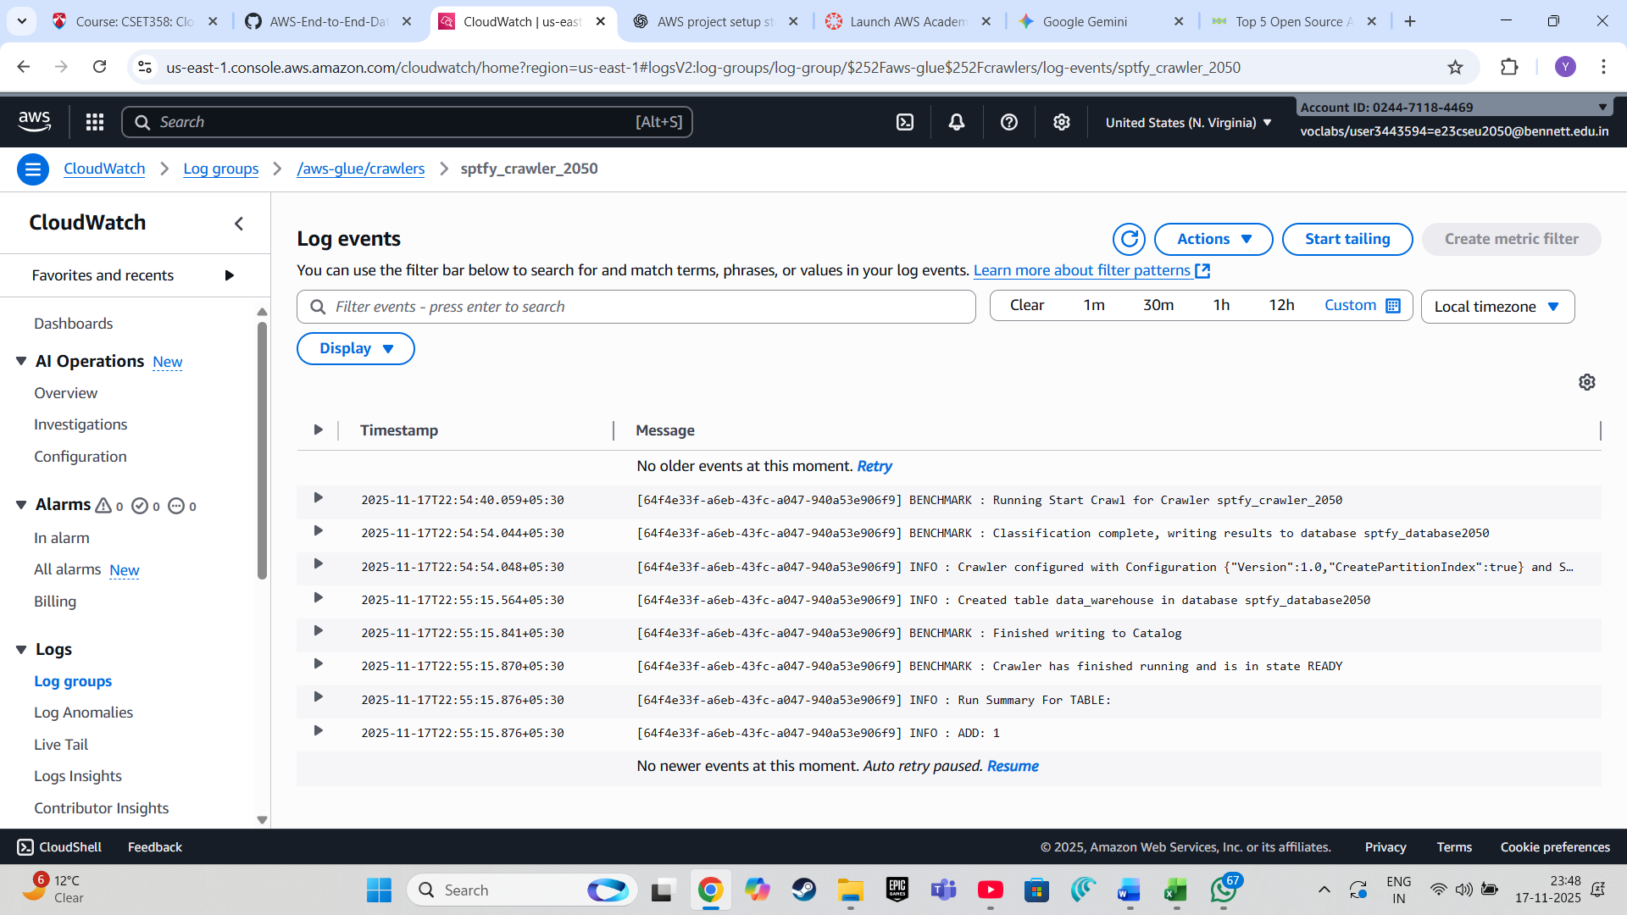

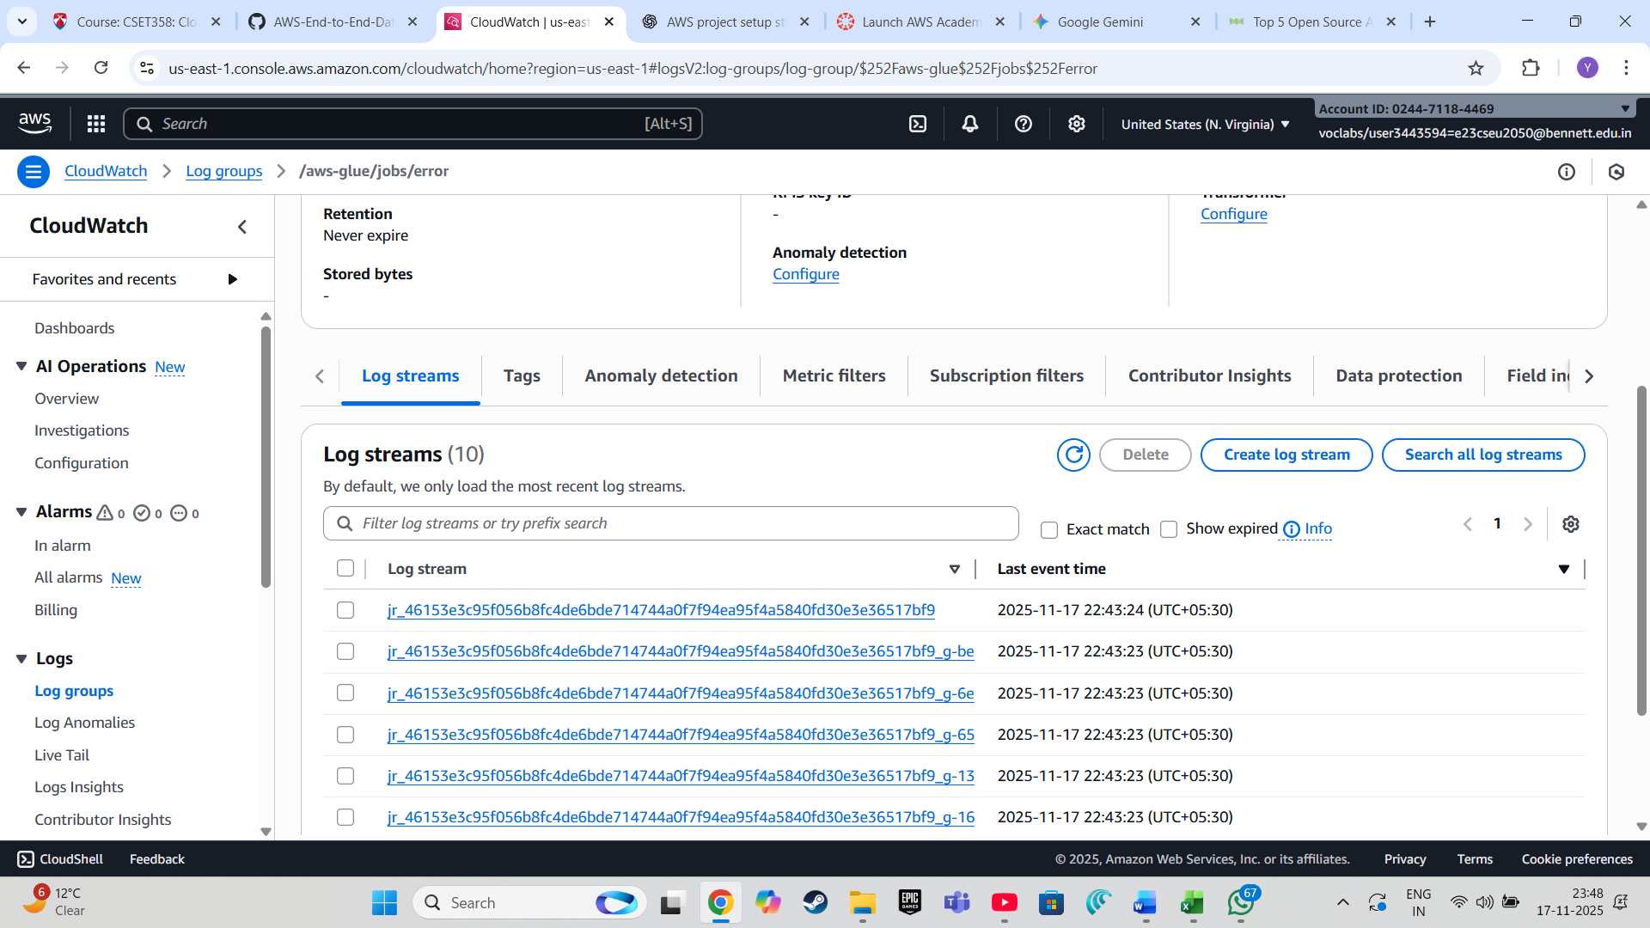

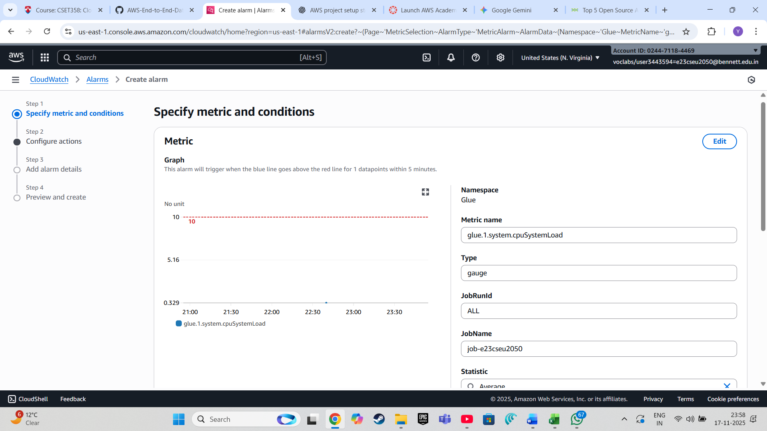

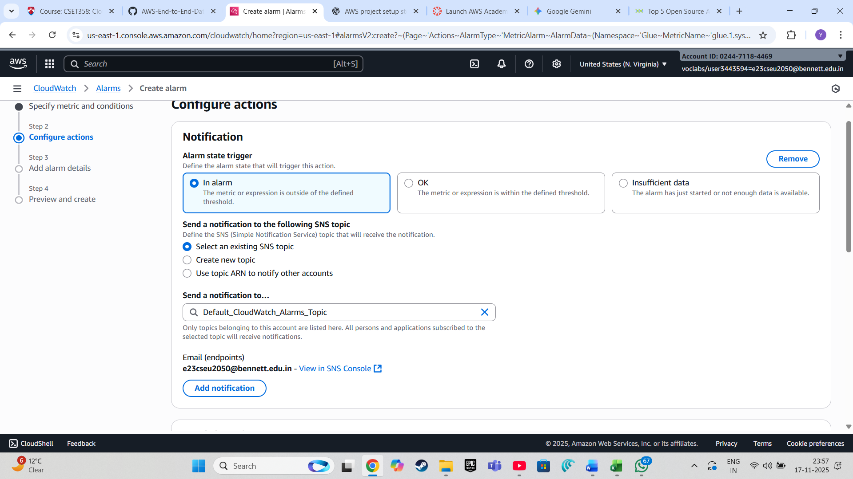

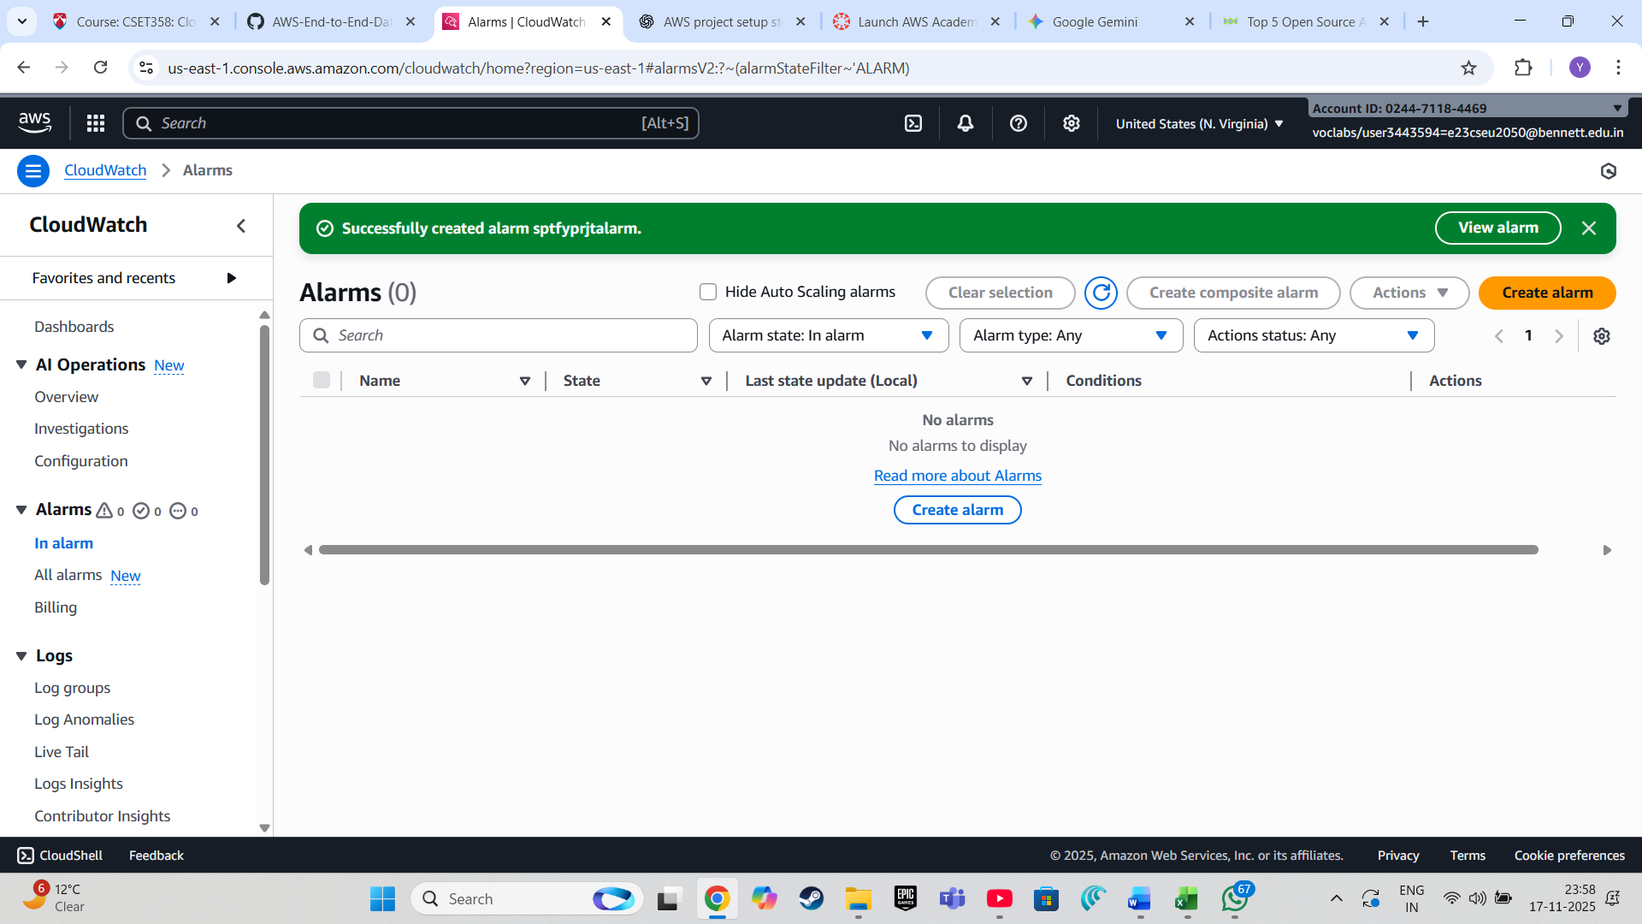

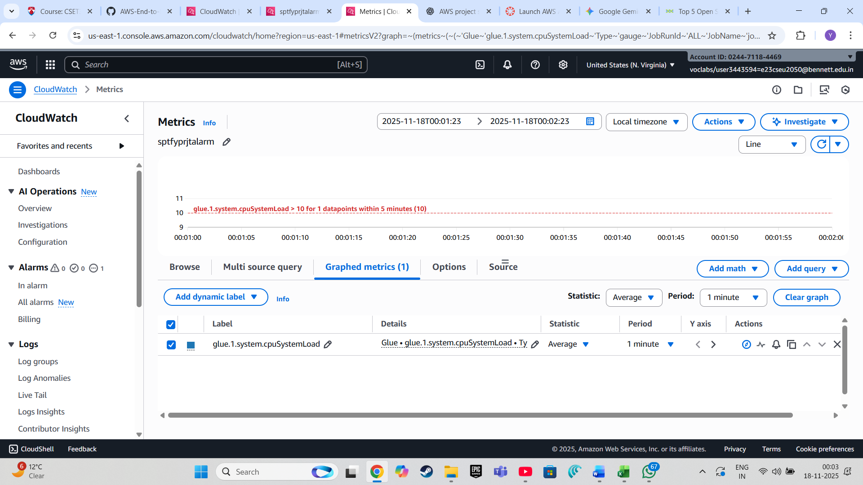

**Conclusion**

This document serves as a runbook for the **Spotify Data Engineering Project**. Follow each step to set up and run your end-to-end data pipeline.

**Real-World Applications**

The insights gained from this project can be applied in various real-world scenarios:

1. **Music Recommendations:** By analyzing the popularity of tracks and artists, platforms can improve their recommendation engines.
2. **Market Analysis:** Record labels and music producers can use the data to understand trends and make informed decisions on which genres or artists to promote.
3. **User Engagement:** Streaming services can analyze user preferences and behavior to enhance user engagement through personalized playlists and features.
4. **Business Intelligence:** The visualizations and insights derived can help business analysts make data-driven decisions to optimize marketing strategies and improve user retention